

Faculty of Engineering (Degree)
Semester – 1
Subject Name – Programming for Problem Solving
Subject Code – BE200104
Faculty Name – Ashwini Walake
Unit -3: Operators and Expressions in C

C Operators :
Operators in C are special symbols used to perform operations on variables, constants, and expressions. They form expressions.
C operators can be classified as,
1. Arithmetic operators
2. Relational operators
3. Logical operators
4. Assignment operators
5. Increment or Decrement operators
6. Conditional operator
7. Bit wise operators
8. Special operators
1. ARITHMETIC OPERATORS:
All basic arithmetic operators are present in C.
The arithmetic operators are used to perform mathematical calculations such as addition, subtraction, multiplication, division, and modulus on numeric values.
- Work with integer and floating-point data types.
- Include unary operators like increment (++) and decrement (--)
Example:
#include <stdio.h>
int main() {
int a = 25, b = 5;
// using operators and printing results
printf("a + b = %d\n", a + b);
printf("a - b = %d\n", a - b);
printf("a * b = %d\n", a * b);
printf("a / b = %d\n", a / b);
printf("a %% b = %d\n", a % b);
printf("+a = %d\n", +a);
printf("-a = %d\n", -a);
printf("a++ = %d\n", a++);
printf("a-- = %d\n", a--);

return 0;
}
Output
a + b = 30
a - b = 20
a * b = 125
a / b = 5
a % b = 0
+a = 25
-a = -25
a++ = 25
a-- = 26

2.RELATIONAL OPERATORS:
The relational operators compare two values and determine the relationship between them. The result of a relational operation is either true (1) or false (0).
- Return boolean-like results (0 or 1).
- Used in decision-making statements.

Example:
#include <stdio.h>
int main() {
int a = 25, b = 5;

// using operators and printing results
printf("a < b : %d\n", a < b);
printf("a > b : %d\n", a > b);
printf("a <= b: %d\n", a <= b);
printf("a >= b: %d\n", a >= b);
printf("a == b: %d\n", a == b);
printf("a != b : %d\n", a != b);

return 0;
}
Output
a < b : 0
a > b : 1
a <= b: 0
a >= b: 1
a == b: 0
a != b : 1
Here, 0 means false and 1 means true.

3.LOGICAL OPERATORS:
Logical Operators are used to combine multiple conditions or reverse a condition's result. They evaluate expressions and return either true or false.
- Return logical results (true or false).
- Support AND (&&), OR (||), and NOT (!) operations.

Symbol | Operator Name | Description | Example
&& | Logical AND | Returns 1 only if both operands are non-zero. | (5 > 3) && (2 < 4) results in 1
|| | Logical OR | Returns 1 if at least one operand is non-zero. | (5 > 3) || (2 > 4) results in 1
! | Logical NOT | Reverses the logical state (turns true to 0, false to 1). | !(5 > 3) results in 0

Truth Table Reference
This table displays the output values for all combinations of input expressions A and B:
A | B | A && B | A || B | !A
0 (False) | 0 (False) | 0 | 0 | 1
0 (False) | Non-zero (True) | 0 | 1 | 1
Non-zero (True) | 0 (False) | 0 | 1 | 0
Non-zero (True) | Non-zero (True) | 1 | 1 | 0

Example:
#include <stdio.h>
int main() {
int a = 25, b = 5;
// using operators and printing results
printf("a && b : %d\n", a && b);
printf("a || b : %d\n", a || b);
printf("!a: %d\n", !a);
return 0;
}
Output
a && b : 1
a || b : 1
!a: 0

4. BITWISE OPERATORS:
The Bitwise operators perform operations directly on the binary representation of integers. They are widely used in low-level programming and performance-critical applications.
- Useful for flags, masks, and hardware programming.
- Generally faster than equivalent arithmetic operations.

Operator | Name | Logic / Behavior
& | Bitwise AND | Result bit is 1 if both input bits are 1.
| | Bitwise OR | Result bit is 1 if at least one input bit is 1.
^ | Bitwise XOR | Result bit is 1 if input bits are different.
~ | Bitwise NOT | Flips all bits (1 becomes 0, 0 becomes 1).
<< | Left Shift | Shifts bits left, fills empty slots on the right with 0.
>> | Right Shift | Shifts bits right, drops trailing bits.

Example:
#include <stdio.h>
int main() {
int a = 25, b = 5;
// using operators and printing results
printf("a & b: %d\n", a & b);
printf("a | b: %d\n", a | b);
printf("a ^ b: %d\n", a ^ b);
printf("~a: %d\n", ~a);
printf("a >> b: %d\n", a >> b);
printf("a << b: %d\n", a << b);

return 0;
}
Output
a & b: 1
a | b: 29
a ^ b: 28
~a: -26
a >> b: 0
a << b: 800

5. ASSIGNMENT OPERATORS
Assignment operators are used to assign values to variables. Compound assignment operators combine assignment with another operation, making code shorter and more readable.
- Simplify expressions using compound operators.
- Improve code readability.
- Overview of Assignment Operators
Operator | Name | Example | Equivalent Meaning
= | Simple Assignment | x = 5; | x = 5;
+= | Addition Assignment | x += 3; | x = x + 3;
-= | Subtraction Assignment | x -= 3; | x = x - 3;
*= | Multiplication Assignment | x *= 3; | x = x * 3;
/= | Division Assignment | x /= 3; | x = x / 3;
%= | Modulus Assignment | x %= 3; | x = x % 3;
&= | Bitwise AND Assignment | x &= 3; | x = x & 3;
|= | Bitwise OR Assignment | x |= 3; | x = x | 3;
^= | Bitwise XOR Assignment | x ^= 3; | x = x ^ 3;
<<= | Bitwise Left Shift Assignment | x <<= 2; | x = x << 2;
>>= | Bitwise Right Shift Assignment | x >>= 2; | x = x >> 2;
Example:
#include <stdio.h>

int main() {
int a = 25, b = 5;
// using operators and printing results
printf("a = b: %d\n", a = b);
printf("a += b: %d\n", a += b);
printf("a -= b: %d\n", a -= b);
printf("a *= b: %d\n", a *= b);
printf("a /= b: %d\n", a /= b);
printf("a %%= b: %d\n", a %= b);
printf("a &= b: %d\n", a &= b);
printf("a |= b: %d\n", a |= b);
printf("a ^= b: %d\n", a ^= b);
printf("a >>= b: %d\n", a >>= b);
printf("a <<= b: %d\n", a <<= b);
return 0;
}
Output
a = b: 5
a += b: 10
a -= b: 5
a *= b: 25
a /= b: 5
a %= b: 0
a &= b: 0
a |= b: 5
a ^= b: 0
a >>= b: 0
a <<= b: 0

6. CONDITIONAL OPERATOR ( ? : )
The conditional operator is the only ternary operator in C. It is a conditional operator that we can use in place of if..else statements.
Syntax
expression1 ? Expression2 : Expression3;
Here, Expression1 is the condition to be evaluated. If the condition(Expression1) is True then we will execute and return the result of Expression2 otherwise if the condition(Expression1) is false then we will execute and return the result of Expression3.
7. UNARY OPERATORS:
The increment operator (++) and decrement operator (--) in C are unary operators used to increase or decrease the value of a variable by exactly 1. They are commonly used for loops, array traversal, and counter management.
Types of Operators
These operators behave differently based on whether they are placed before (prefix) or after (postfix) the variable.
Operator | Type | Description
++a | Prefix Increment | Increments a by 1 first, then returns the updated value.
a++ | Postfix Increment | Returns the current value of a first, then increments a by 1.
--a | Prefix Decrement | Decrements a by 1 first, then returns the updated value.
a-- | Postfix Decrement | Returns the current value of a first, then decrements a by 1.

Arithmetic Expression
You may have seen mathematical phrases like 13 + 2, 20 – 4, 12 × 5, and 18 ÷ 3. Such phrases are called arithmetic expressions. Every arithmetic expression has a value which is the number it evaluates to. For example, the value of the expression 13 + 2 is 15. This expression can be read as ‘13 plus 2’ or ‘the sum of 13 and 2’. We use the equality sign ‘=’ to denote the relationship between an arithmetic expression and its value. For example: 13 + 2 = 15.

Operator Precedence and Associativity in C
Operator precedence and associativity are rules that decide the order in which parts of an expression are calculated. Precedence tells us which operators should be evaluated first, while associativity determines the direction (left to right or right to left) in which operators with the same precedence are evaluated.
Let's take a look at an example:
#include <stdio.h>
int main() {
int a = 6, b = 3, c = 4;
int res;
// Precedence and associativity applied here
res = a + b * c / 2;
printf("%d", res);
return 0;
}
Output
12
Explanation: The above expression is evaluated as 6 + ( (3 * 4) / 2) = 12, not (6 + 3) * (4 / 2) = 18. So what guided the compiler to evaluate the expression in this way? It is actually the precedence and associativity of the operators used in this expression.
In this article, let's discuss operator precedence, operator associativity, and the precedence table that determines the priority of operators in expressions in C language.

Operator Precedence
Operator precedence determines which operation is performed first in an expression with more than one operator with different precedence. Let's try to evaluate the following expression,
10 + 20 * 30
The expression contains two operators, + (addition) and * (multiplication). According to operator precedence, multiplication (*) has higher precedence than addition (+), so multiplication is checked first. After evaluating multiplication, the addition operator is then evaluated to give the final result.
We can verify this using the following C program
#include <stdio.h>
int main() {
// Printing the value of same expression
printf("%d", 10 + 20 * 30);
return 0;
}
Output
610
As we can see, the expression is evaluated as,10 + (20 * 30) but not as (10 + 20) * 30 due to * operator having higher precedence.
Operator Associativity
Operator associativity is used when two operators of the same precedence appear in an expression. Associativity can be either from Left to Right or Right to Left. Let's evaluate the following expression,
100 / 5 % 2
The division (/) and modulus (%) operators have the same precedence, so the order in which they are evaluated depends on their left-to-right associativity. This means the division is performed first, followed by the modulus operation. After the calculations, the result of the modulus operation is determined.
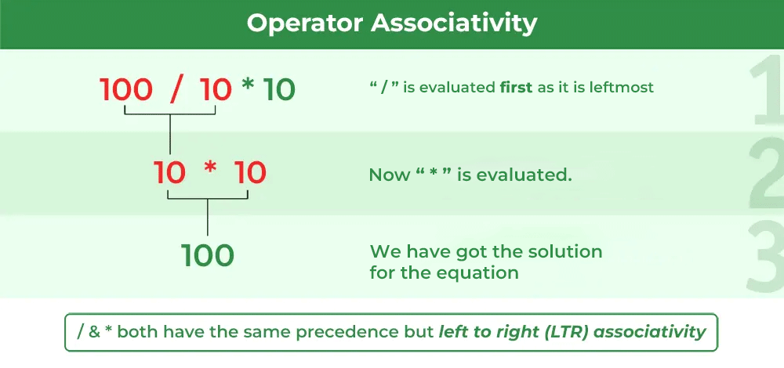
We can verify the above using the following C program:
#include <stdio.h>
int main() {
// Verifying the result of the same expression
printf("%d", 100 / 5 % 2);
return 0;
}
Output
0
Operators Precedence and Associativity are two characteristics of operators that determine the evaluation order of sub-expressions.
Example of Operator Precedence and Associativity
In general, operator precedence and associativity are applied together in expressions. Consider the expression exp = 100 + 200 / 10 - 3 * 10, where the division (/) and multiplication (*) operators have the same precedence but are evaluated before addition (+) and subtraction (-). Due to left-to-right associativity, the division is evaluated first, followed by multiplication. After evaluating the division and multiplication, the addition and subtraction are evaluated from left to right, giving the final result.
Again, we can verify this using the following C program.
#include <stdio.h>
int main() {
// getting the result of the same expression as the
// example
int exp = 100 + 200 / 10 - 3 * 10;
printf("%d", exp);
return 0;
}
Output
90
Operator Precedence and Associativity Table
The following tables list the C operator precedence from highest to lowest and the associativity for each of the operators:
Precedence | Operator | Description | Associativity
1 | () | Parentheses (function call) | Left-to-Right
1 | [] | Array Subscript (Square Brackets) | Left-to-Right
1 | . | Dot Operator | Left-to-Right
1 | -> | Structure Pointer Operator | Left-to-Right
1 | ++ , -- | Postfix increment, decrement | Left-to-Right
2 | ++ / -- | Prefix increment, decrement | Right-to-Left
2 | + / - | Unary plus, minus | Right-to-Left
2 | ! , ~ | Logical NOT, Bitwise complement | Right-to-Left
2 | (type) | Cast Operator | Right-to-Left
2 | * | Dereference Operator | Right-to-Left
2 | & | Addressof Operator | Right-to-Left
2 | sizeof | Determine size in bytes | Right-to-Left
3 | *,/,% | Multiplication, division, modulus | Left-to-Right
4 | +/- | Addition, subtraction | Left-to-Right
5 | << , >> | Bitwise shift left, Bitwise shift right | Left-to-Right
6 | < , <= | Relational less than, less than or equal to | Left-to-Right
 | > , >= | Relational greater than, greater than or equal to
7 | == , != | Relational is equal to, is not equal to | Left-to-Right
8 | & | Bitwise AND | Left-to-Right
9 | ^ | Bitwise exclusive OR | Left-to-Right
10 | | | Bitwise inclusive OR | Left-to-Right
11 | && | Logical AND | Left-to-Right
12 | || | Logical OR | Left-to-Right
13 | ?: | Ternary conditional | Right-to-Left
14 | = | Assignment | Right-to-Left
 | += , -= | Addition, subtraction assignment
 | *= , /= | Multiplication, division assignment
 | %= , &= | Modulus, bitwise AND assignment
 | ^= , |= | Bitwise exclusive, inclusive OR assignment
 | <<=, >>= | Bitwise shift left, right assignment
15 | , | comma (expression separator) | Left-to-Right

Type Conversion in C
In C, type conversion refers to the process of converting one data type to another. It can be done automatically by the compiler or manually by the programmer. The type conversion is only performed to those data types where conversion is possible.
Let's take a look at an example:
#include <stdio.h>
int main() {
float f1 = 5.5;
int a;
// Automatic type conversion from float to int
a = f1;
// Manual type conversion from int to float
float f2 = (float)a;
printf("a: %d\n", a);
printf("f1: %f\n", f1);
printf("f2: %f", f2);
return 0;
}
Output
a: 5
f1: 5.500000(Note:By default, it prints 6 digits after decimal, even if they are zeros.)
f2: 5.000000
Explanation: In the above program, when f1 is assigned to int a, its value is automatically converted to integer first and then assigned to a. On the other hand, we manually convert the value of a to assign it to float variable f2.
The automatic type conversion performed by the compiler is called Implicit Type Conversion and the manual one done by the programmer is called Explicit Type Conversion.

Implicit Type Conversion
Implicit type conversion, also known as type coercion, occurs when the C compiler automatically converts one data type to another without the need for explicit instructions from the programmer. This typically happens when a smaller data type is assigned to a larger data type or when different data types are involved in an arithmetic operation.
For example, if an integer is added to a float, the integer is implicitly converted to a float, and the result is a float.
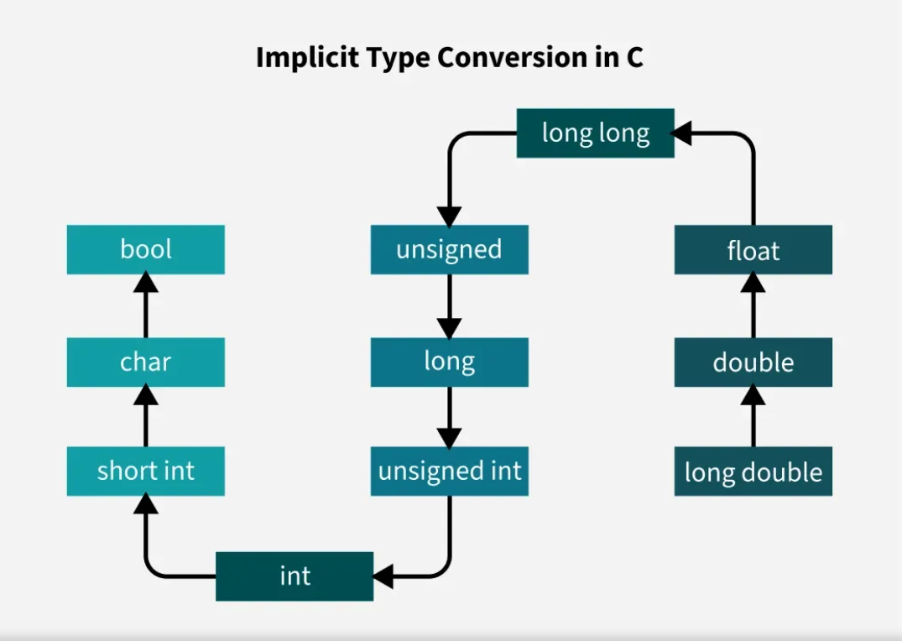
Example
#include <stdio.h>
int main() {
int n1 = 5;
float n2 = 4.5;
// Implicit type conversion from int to float
float result = n1 + n2;
printf("%.2f\n", result);
return 0;
}
Output
9.50
Explanation: In this code, implicit type conversion occurs when n1 (int) is automatically converted to a float during the expression n1 + n2 to match the type of n2.
Example
#include <stdio.h>
int main() {
int n1 = 5;
float n2 = 4.5;
// Implicit type conversion from int to float
float result = n1 + n2;
printf("%.2f\n", result);
return 0;
}
Output
9.50
Explanation: In this code, implicit type conversion occurs when n1 (int) is automatically converted to a float during the expression n1 + n2 to match the type of n2.

Explicit Type Conversion
Explicit type conversion, or typecasting, occurs when the programmer explicitly tells the compiler to convert a variable from one type to another. This is done using the casting operator (type).
Syntax
(type) expression
where type indicates the final data type to which the expression is converted.
Example
#include <stdio.h>
int main() {
float n1 = 7.9;
int n2;
// Explicit type conversion (casting)
// from float to int
n2 = (int)n1;
printf("%d", n2);
return 0;
}
Output: 7
Explanation: In this example, the float n1 is manually cast to an integer using (int)n1. This conversion truncates the decimal part, resulting in the integer value being assigned to n2.

C Library Math.H Functions
The math.h header defines various C mathematical functions and one macro. All the functions available in this library take double as an argument and return double as the result. Let us discuss some important C math functions one by one.

C Math Functions
1. double ceil (double x)
The C library function double ceil (double x) returns the smallest integer value greater than or equal to x.
Syntax
double ceil(double x);
Example
// C code to illustrate
// the use of ceil function.
#include <math.h>
#include <stdio.h>
int main()
{
float val1, val2, val3, val4;
val1 = 1.6;
val2 = 1.2;
val3 = -2.8;
val4 = -2.3;
printf("value1 = %.1lf\n", ceil(val1));
printf("value2 = %.1lf\n", ceil(val2));
printf("value3 = %.1lf\n", ceil(val3));
printf("value4 = %.1lf\n", ceil(val4));
return (0);
}
Output
value1 = 2.0 (smallest integer ≥ 1.6 is 2)
value2 = 2.0 (smallest integer ≥ 1.2 is 2)
value3 = -2.0 (smallest integer ≥ -2.8 is -2)
value4 = -2.0 (smallest integer ≥ -2.3 is -2)

Key Notes
- For positive numbers, ceil() rounds up to the next integer.
- For negative numbers, ceil() rounds towards zero (less negative).

2. double floor(double x)
The C library function double floor(double x) returns the largest integer value less than or equal to x.
Syntax
double floor(double x);
Example
// C code to illustrate
// the use of floor function
#include <math.h>
#include <stdio.h>
int main()
{
float val1, val2, val3, val4;
val1 = 1.6;
val2 = 1.2;
val3 = -2.8;
val4 = -2.3;
printf("Value1 = %.1lf\n", floor(val1));
printf("Value2 = %.1lf\n", floor(val2));
printf("Value3 = %.1lf\n", floor(val3));
printf("Value4 = %.1lf\n", floor(val4));
return (0);
}
Output
Value1 = 1.0 (largest integer ≤ 1.6 is 1)
Value2 = 1.0 (largest integer ≤ 1.2 is 1)
Value3 = -3.0 (largest integer ≤ -2.8 is -3)
Value4 = -3.0 (largest integer ≤ -2.3 is -3)
Note
- floor(x) → rounds down to the nearest integer.
Example with -2.8:
- floor(-2.8) = -3.0

3. double fabs(double x)
The C library function double fabs(double x) returns the absolute value of x.
Syntax
syntax : double fabs(double x)
Example
// C code to illustrate
// the use of fabs function
#include <math.h>
#include <stdio.h>
int main()
{
int a, b;
a = 1234;
b = -344;
printf("The absolute value of %d is %lf\n", a, fabs(a));
printf("The absolute value of %d is %lf\n", b, fabs(b));
return (0);
}
Output
The absolute value of 1234 is 1234.000000
The absolute value of -344 is 344.000000

4. double log(double x)
The C library function double log(double x) returns the natural logarithm (base-e logarithm) of x.
Syntax
double log(double x)
Example
// C code to illustrate
// the use of log function
#include <math.h>
#include <stdio.h>
int main()
{
double x, ret;
x = 2.7;
/* finding log(2.7) */
ret = log(x);
printf("log(%lf) = %lf", x, ret);
return (0);
}
Output
log(2.700000) = 0.993252

5. double log10(double x)
The C library function double log10(double x) returns the common logarithm (base-10 logarithm) of x.
Syntax
double log10(double x);
Example
// C code to illustrate
// the use of log10 function
#include <math.h>
#include <stdio.h>
int main()
{
double x, ret;
x = 10000;
/* finding value of log1010000 */
ret = log10(x);
printf("log10(%lf) = %lf\n", x, ret);
return (0);
}
Output
log10(10000.000000) = 4.000000

6. double fmod(double x, double y)
The C library function double fmod(double x, double y) returns the remainder of x divided by y.
Syntax
double fmod(double x, double y)
Example
// C code to illustrate
// the use of fmod function
#include <math.h>
#include <stdio.h>
int main()
{
float a, b;
int c;
a = 8.2;
b = 5.7;
c = 3;
printf("Remainder of %f / %d is %lf\n", a, c,
fmod(a, c));
printf("Remainder of %f / %f is %lf\n", a, b,
fmod(a, b));
return (0);
}
Output
Remainder of 8.200000 / 3 is 2.200000
Remainder of 8.200000 / 5.700000 is 2.500000

7. double sqrt(double x)
The C library function double sqrt(double x) returns the square root of x.
Syntax
double sqrt(double x);
Example
// C code to illustrate
// the use of sqrt function
#include <math.h>
#include <stdio.h>
int main()
{
printf("Square root of %lf is %lf\n", 225.0,
sqrt(225.0));
printf("Square root of %lf is %lf\n", 300.0,
sqrt(300.0));
return (0);
}
Output
Square root of 225.000000 is 15.000000
Square root of 300.000000 is 17.320508
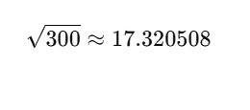

8. double pow(double x, double y)
The C library function double pow(double x, double y) returns x raised to the power of y i.e. xy.
Syntax
double pow(double x, double y);
Example
// C code to illustrate
// the use of pow function
#include <math.h>
#include <stdio.h>
int main()
{
printf("Value 8.0 ^ 3 = %lf\n", pow(8.0, 3));
printf("Value 3.05 ^ 1.98 = %lf", pow(3.05, 1.98));
return (0);
}
Output
Value 8.0 ^ 3 = 512.000000
Value 3.05 ^ 1.98 = 9.097324

